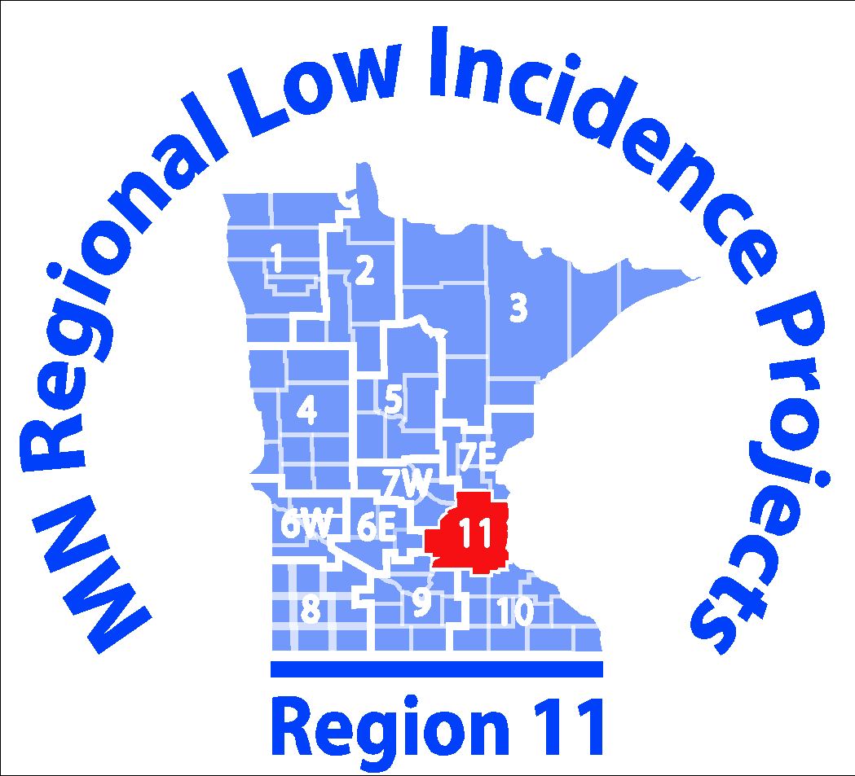
ASD Community of Practice
Region 11 South
Regional Meeting Agenda
September 20, 2018
12:30-1:00 Introduction of new members and networking lunch (bring your own lunch & beverage)
- Please enter your correct email address to the document on the shared drive
- If you don’t have access, let DiAnn or Kris know
1:00-1:30 Review purpose of our network group, roles & responsibilities as reps from our respective districts
- 2 substitutes per district meeting
- Share information back with your districts and teams
Goals this year:
- The MN Region 11 South ASD CoP will increase parent involvement, early childhood/pre-school outcomes and FAPE by offering 4 free, evening workshops throughout the 2018-2019 school year.
- The Region 11 South ASD CoP will increase professional development with our district representitives by providing structured and planned opportunities for staff to share resources, problem-solve, and learn from each other at least 4 of the 5 regional meetings during the 2018-2019 school year.
1:30-2:00 Access the shared Google drive and review group goals for 2018-2019 school year and plans made in spring.
- Adjust as needed
2:00-3:00
- Make and Take date and location
- Topics for this year: Private providers coordination (i.e. Partners in Excellence), Gallery walk of EBPs, 2-3 PD sessions
3:00-3:30 Whip-share
- How your year is starting
- Topics for upcoming meetings

Funding for this workshop is made possible with a grant from the MN Department of Education. The source of the funds is federal award Special Education - Programs to States, CFDA 84.027A AND CFDA 84.173 Special Education-Preschool Grants and 84.181 Special Education Grants for Infants and Family.

